**GENERAL LAB SAFETY RULES**

* The following are rules that relate to almost every laboratory and should be included in most safety policies. They cover what you should know in the event of an emergency, proper signage, safety equipment, safely using laboratory equipment, and basic common-sense rules.
* Be sure to read all fire alarm and safety signs and follow the instructions in the event of an accident or emergency.
* Ensure you are fully aware of your facility's/building's evacuation procedures.
* Make sure you know where your lab's safety equipment—including first aid kit(s), fire extinguishers, eye wash stations, and safety showers—is located and how to properly use it.
* Know emergency phone numbers to use to call for help in case of an emergency.
* Lab areas containing carcinogens, radioisotopes, biohazards, and lasers should be properly marked with the appropriate warning signs.
* Open flames should never be used in the laboratory unless you have permission from a qualified supervisor.
* Make sure you are aware of where your lab's exits and fire alarms are located.
* An area of 36" diameter must be kept clear at all times around all fire sprinkler heads.
* If there is a fire drill, be sure to turn off all electrical equipment and close all containers.
* Always work in properly-ventilated areas.
* Do not chew gum, drink, or eat while working in the lab.
* Laboratory glassware should never be utilized as food or beverage containers.
* Each time you use glassware, be sure to check it for chips and cracks. Notify your lab supervisor of any damaged glassware so it can be properly disposed of.
* Never use lab equipment that you are not approved or trained by your supervisor to operate.
* If an instrument or piece of equipment fails during use, or isn't operating properly, report the issue to a technician right away. Never try to repair an equipment problem on your own.
* If you are the last person to leave the lab, make sure to lock all the doors and turn off all ignition sources.
* Do not work alone in the lab.
* Never leave an ongoing experiment unattended.
* Never lift any glassware, solutions, or other types of apparatus above eye level.
* Never smell or taste chemicals.
* Do not pipette by mouth.
* Make sure you always follow the proper procedures for disposing lab waste.
* Report all injuries, accidents, and broken equipment or glass right away, even if the incident seems small or unimportant.
* If you have been injured, yell out immediately and as loud as you can to ensure you get help.
* In the event of a chemical splashing into your eye(s) or on your skin, immediately flush the affected area(s) with running water for at least 20 minutes.
* If you notice any unsafe conditions in the lab, let your supervisor know as soon as possible.

**HOUSEKEEPING SAFETY RULES**

* 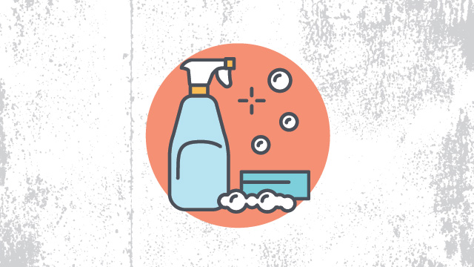
* Laboratory housekeeping rules also apply to most facilities and deal with the basic upkeep, tidiness, and maintenance of a safe laboratory.
* Always keep your work area(s) tidy and clean.
* Make sure that all eye wash stations, emergency showers, fire extinguishers, and exits are always unobstructed and accessible.
* Only materials you require for your work should be kept in your work area. Everything else should be stored safely out of the way.
* Only lightweight items should be stored on top of cabinets; heavier items should always be kept at the bottom.
* Solids should always be kept out of the laboratory sink.
* Any equipment that requires air flow or ventilation to prevent overheating should always be kept clear.

**DRESS CODE SAFETY RULE**

* 
* As you’d expect, laboratory dress codes set a clear policy for the clothing employees should avoid wearing in order to prevent accidents or injuries in the lab. For example skirts and shorts might be nice for enjoying the warm weather outside, but quickly become a liability in the lab where skin can be exposed to heat or dangerous chemicals.
* Always tie back hair that is chin-length or longer.
* Make sure that loose clothing or dangling jewelry is secured, or avoid wearing it in the first place.
* Never wear sandals or other open-toed shoes in the lab. Footwear should always cover the foot completely.
* Never wear shorts or skirts in the lab.
* When working with Bunsen burners, lighted splints, matches, etc., acrylic nails are not allowed.

**PERSONAL PROTECTION SAFETY RULES**

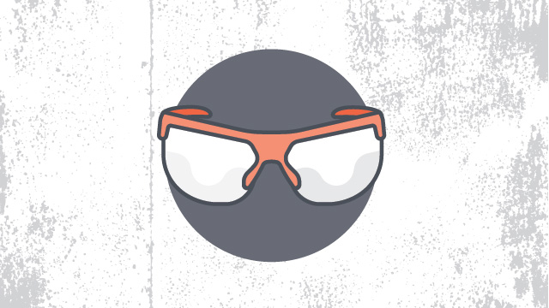

* Unlike laboratory dress code policies, rules for personal protection cover what employees *should* be wearing in the lab in order to protect themselves from various hazards, as well as basic hygiene rules to follow to avoid any sort of contamination.
* When working with equipment, hazardous materials, glassware, heat, and/or chemicals, always wear face shields or safety glasses.
* When handling any toxic or hazardous agent, always wear the appropriate gloves.
* When performing laboratory experiments, you should always wear a smock or lab coat.
* Before leaving the lab or eating, always wash your hands.
* After performing an experiment, you should always wash your hands with soap and water.
* When using lab equipment and chemicals, be sure to keep your hands away from your body, mouth, eyes, and face.

**CHEMICAL SAFETY RULES**

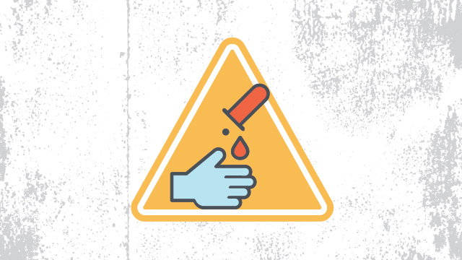

* Since almost every lab uses chemicals of some sort, chemical safety rules are a must. Following these policies helps employees avoid spills and other accidents, as well as damage to the environment outside of the lab. These rules also set a clear procedure for employees to follow in the event that a spill does occur, in order to ensure it is cleaned up properly and injuries are avoided.
* Every chemical should be treated as though it were dangerous.
* Do not allow any solvent to come into contact with your skin.
* All chemicals should always be clearly labeled with the name of the substance, its concentration, the date it was received, and the name of the person responsible for it.
* Before removing any of the contents from a chemical bottle, read the label twice.
* Never take more chemicals from a bottle than you need for your work.
* Do not put unused chemicals back into their original container.
* Chemicals or other materials should never be taken out of the laboratory.
* Chemicals should never be mixed in sink drains.
* Flammable and volatile chemicals should only be used in a fume hood.
* If a chemical spill occurs, clean it up right away.
* Ensure that all chemical waste is disposed of properly.

**CHEMISTRY LAB SAFETY RULES**

* As chemistry labs are one of the most common types, these basic chemistry lab safety rules are relevant to many scientists, dealing with the safe performance of common activities and tasks in the average chemistry lab:
* Before you start an experiment, make sure you are fully aware of the hazards of the materials you'll be using.
* When refluxing, distilling, or transferring volatile liquids, always exercise extreme caution.
* Always pour chemicals from large containers to smaller ones.
* Never pour chemicals that have been used back into the stock container.
* Never tap flasks that are under vacuum.
* Chemicals should never be mixed, measured, or heated in front of your face.
* Water should not be poured into concentrated acid. Instead, pour acid slowly into water while stirring constantly. In many cases, mixing acid with water is exothermic.

**ELECTRICAL SAFTEY RULES**

* 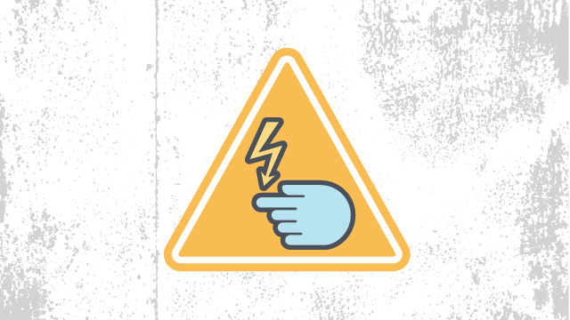
* Like almost every other workplace, laboratories contain electronic equipment. Electrical safety rules help prevent the misuse of electronic instruments, electric shocks and other injuries, and ensure that any damaged equipment, cords, or plugs are reported to the appropriate authorities so they can be repaired or replaced.
* Before using any high voltage equipment (voltages above 50Vrms ac and 50V dc), make sure you get permission from your lab supervisor.
* High voltage equipment should never be changed or modified in any way.
* Always turn off a high voltage power supply when you are attaching it.
* Use only one hand if you need to adjust any high voltage equipment.  It's safest to place your other hand either behind your back or in a pocket.
* Make sure all electrical panels are unobstructed and easily accessible.
* Whenever you can, avoid using extension cords.

**LASER SAFETY RULES**

* 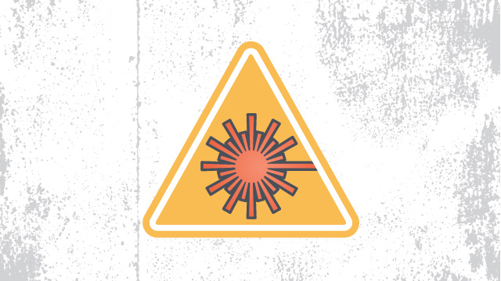
* Perhaps not as common as some of the other laboratory safety rules listed here, many laboratories do use lasers and it’s important to follow some key rules of thumb to prevent injuries. In particular, accidents due to reflection are something that many employees may not think about. A clear set of rules for the use of lasers is essential to ensure that everyone is aware of all hazards and that the appropriate personal protective equipment is worn at all times.
* Even if you are certain that a laser beam is "eye" safe or low power, you should never look into it.
* Always wear the appropriate goggles in areas of the lab where lasers are present. The most common laser injuries are those caused by scattered laser light reflecting either off the shiny surface of optical tables, the sides of mirrors, or off of mountings. Goggles will help you avoid damage from such scattered light.
* You should never keep your head at the same level as the laser beam.
* Always keep the laser beam at or below chest level.
* Laser beams should never be allowed to spread into the lab. Beam stops should always be used to intercept laser beams.
* Do not walk through laser beams.

### **MACHINE SHOP SAFETY RULE**

#### General

* These job safety rules are in addition to the General Safety Rules. You must know and follow both.
* Workers must not remove or make ineffective any safeguards, unless authorized. Safeguards removed for repairs must be replaced promptly or temporary guards installed.
* Machines and equipment shall be operated by authorized personnel only.
* No machine shall be left unattended while it is in motion.
* Cleaning, oiling or adjusting any machine shall not be done while the machine is in motion.
* Materials to be machined shall be securely fastened or clamped to the working surfaces before starting the machine.
* Keys or other adjusting tools must never be left so that they may creep, be thrown, or fall when machine is started.
* Use a brush, special tool or hook to remove chips, shavings or other material from work. Flowing shavings shall not be handled with bare hands; metal hooks shall be used.
* Revolving shafting, although apparently smooth, will catch loose or ragged clothing, hair or wiping rags. Proper clothes and caution are always necessary when working around any revolving machinery.
* When tightening work in chuck jaws with chuck wrench, operator shall see that wrench fits properly; operator should take proper stance when tightening jaws to prevent falling if wrench slips.
* When placing or removing heavy castings or billets from machines, operator shall get help or crane service to prevent injury.
* Operators shall keep hands away from cutters and bars while operating machines. Operators shall keep hands off work while machine is in operation.
* Operators shall stand so that they can easily reach the machine controls.
* Cutters and tools shall be in the clear before machines are started.
* Clean-up chips, spills, etc., on and around machinery after each use.

#### **LATHES**

* All materials shall be properly secured in chucks and collets before machines are started.
* Do not leave chuck wrench in chuck after removing work from chuck.
* Keep hands off chuck rims when lathe is in motion.
* Do not attempt to screw chuck on lathe spindle with power on, as it may get cross-threaded and cause an accident.
* Safety-type lathe dogs shall be used when turning work on centers.
* See that tail stock, tool holder and work are properly clamped before turning on power.
* It is dangerous to shift step pulley belts with the hands while the belts are in motion with power on; use a belt pole or other suitable stick.
* Do not attempt to adjust a tool while the lathe is running.
* Operators shall not attempt to use micrometers on revolving work.

#### **DRILL PRESS**

* Never attempt to hold the work under the drill by hand; clamp it securely to the table before starting the machine.
* When tightening drill in chuck of drill press, remove release key before you start machine, or your arm may be twisted around spindle. Never leave key in chuck.
* Use drills properly sharpened to cut to the right size.
* Run the drill only at the correct speed; forcing or feeding too fast may cause broken drills and result in serious injury.
* If the work should slip from clamp, never attempt to stop it with your hands. Stop the machine to make any adjustment or repair.
* Drills, reamers, etc., must never be forced by exerting excess pressure on the feed lever. Tools may break and cause injury.

#### **MILLING MACHINE**

* All work shall be secured properly and all loose objects removed from tables before machines are operated.
* Cutters shall be checked for cracks or breaks before mounting and shall be securely mounted before operations are started.
* Operators shall keep head and hands away from cutters when machine is in operation.
* File tangs or other makeshift drifts shall not be used to remove taper shank tools. Proper drifts are available in tool rooms.
* Safety guards shall be placed around any work item extending beyond machine table.
* Milling cutters and other hardened tools shall not be struck with steel hammer. Blocks of wood, rawhide, or copper hammers should be used.
* Proper feeds and speeds shall be selected before operations are started.
* Machines shall be stopped before any attempts are made to measure or to check work.
* Guards and baffles shall be used to protect others from flying chips, oil or coolants.
* Operators shall be sure that cutters and feeds are turning in the proper direction so the cutters will not climb up or jam. Such an accident can cause injury to the work, the machine, and to the operator as well.

#### **OPERATION AND GRINDERS**

* Caution: All grinding wheels operate at dangerous speeds.
* See that the grinding wheel fits easily on the spindle. It is dangerous to force it on, nor should it be too loose.
* Washers or flange facings or compressible material shall be fitted between the wheel and its flanges. If blotting paper is used, it should not be thicker than .025 inch.
* After a wheel is mounted, allow it to develop full operating speed for at least one minute; meanwhile, stand to one side and out of danger. Never apply the work until this speed test has been made and the wheel has been properly dressed. Under no condition should the wheel revolve faster than the safe R.P.M. recommended by the manufacturer as shown on the label.
* Do not force work against a cold wheel, but apply it gradually, giving the wheel an opportunity to warm, thus reducing the chance of breakage. This applies to starting work in the mornings in cold rooms and to new wheels which have been stored in a cold place.
* Wheel dressers, except the diamond type, shall be equipped with guards over the tops of the cutters to protect against flying pieces, broken cutters, or wheel particles.
* Operator shall see that wheel turns freely and is properly mounted before operating.
* All wheels should be given the "ring" test before they are mounted on machines.
* Gloves should not be worn while operating grinders.
* Dust collectors or other exhaust systems shall be in operation during grinding operations on machines so equipped.
* Tools or other loose objects shall be kept off machines in operation.
* Wheel guards shall be kept in place and in good condition while machine is in operation.
* Safe operating speeds are marked on wheels by manufacturers.
* Operators shall not run wheels faster than recommended speeds.
* Operators shall avoid standing directly in front of grinding wheels, especially when starting.
* Wheels loaded or clogged with metal shall not be used until dressed.
* Grinding wheels out of round or out of balance shall be trued before using.
* Eye protective equipment with side shields shall be worn while grinders are being operated.
* Grindings wheels shall be equipped with tool rests, same must not be worn more than one-eighth inch from stone and work held firmly thereon.
* It is unsafe to adjust a work-rest while the grinding wheel is in motion. The rest may slip and break the wheel.
* The side of an emery wheel shall not be used for grinding unless it is a special-type wheel for that purpose.
* Be especially careful when grinding narrow tools. They are apt to catch between the rest and the wheel.

#### **PLANNER,SHAPPER AND SLOTTER**

* Jobs shall be securely mounted and all tools removed from tables before machines are started.
* Machine stroke shall be properly adjusted so as to clear work and machine tables.
* Operators shall stand clear of work that projects over side of planer tables.
* Operators shall not try to adjust stroke or position of ram while cut is being taken.
* Operators should stand so machine controls are easily reached.
* While machines are in operation, hands shall be kept away from clapper boxes. Adjustment shall not be made to tools when clapper boxes are raised.
* Screens shall be provided against flying chips or cuttings to protect other employees working nearby.
* Operators should take proper stance when pulling on long wrenches to bolt down work on machines to prevent falling and strain should the wrench slip.

#### **WELDING**

* All welding operations shall follow the Job Safety Rules for welding.